**Project Development Phase**

**Model Performance Test**

|  |  |
| --- | --- |
| Date | 10 November 2022 |
| Team ID | PNT2022TMID52686 |
| Project Name | Project - Real-Time Communication System Powered by AI for specially abled |
| Maximum Marks | 10 Marks |

**Model Performance Testing:**

Project team shall fill the following information in model performance testing template.

|  |  |  |  |
| --- | --- | --- | --- |
| **S.No.** | **Parameter** | **Values** | **Screenshot** |
|  | Model Summary | Total params : 4,597,661  Trainable params : 4,596,765  Non-trainable params : 896 |  |
|  | Accuracy | Training Accuracy - 0.9920   Validation Accuracy - 0.9951  Validation Precision - 0.9952  Validation Recall - 0.9950 |  |

**CONFUSION MATRIX**

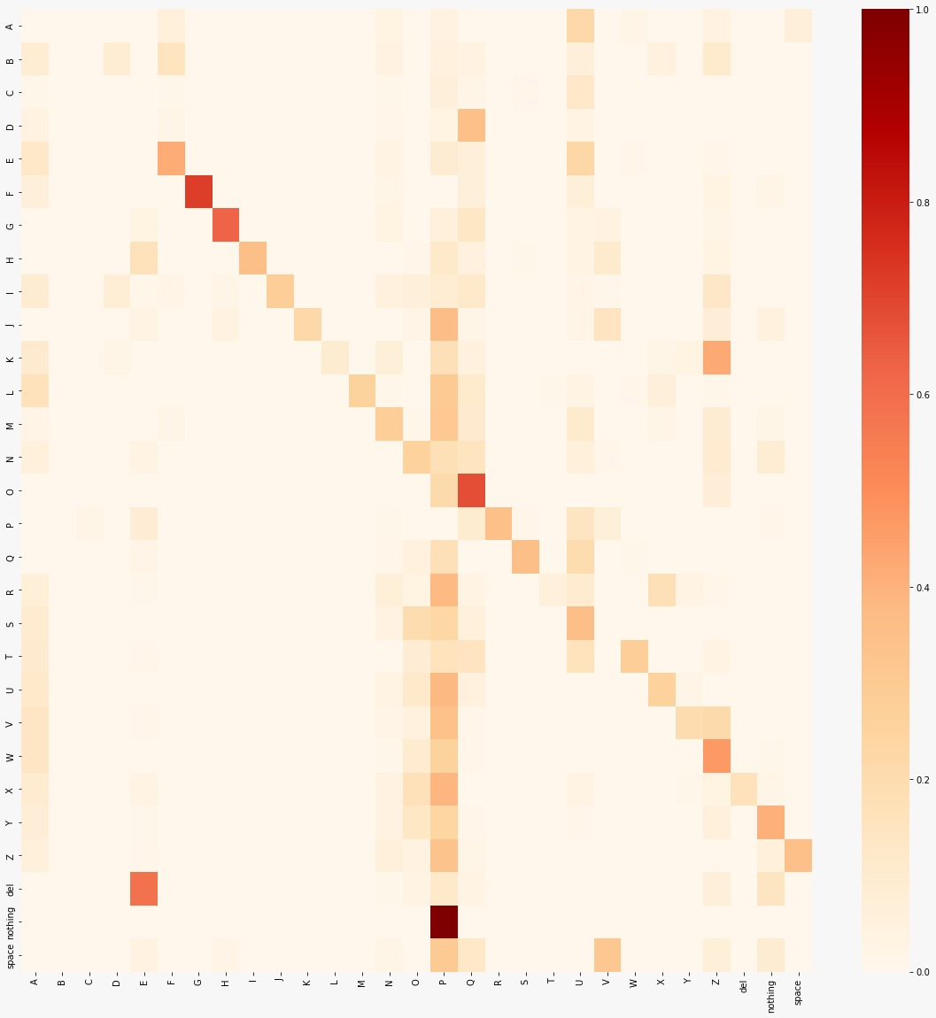

**PR CURVE**

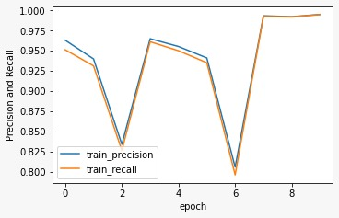

**ROC CURVE**

